1. A Boolean value is either True or False. A Boolean expression is an expression that evaluates to produce a result which is a Boolean value.

e.g 3 != 4

4 >= 8

3 < 1

1. Flowchart is a diagram of the sequence of actions that Python would take.

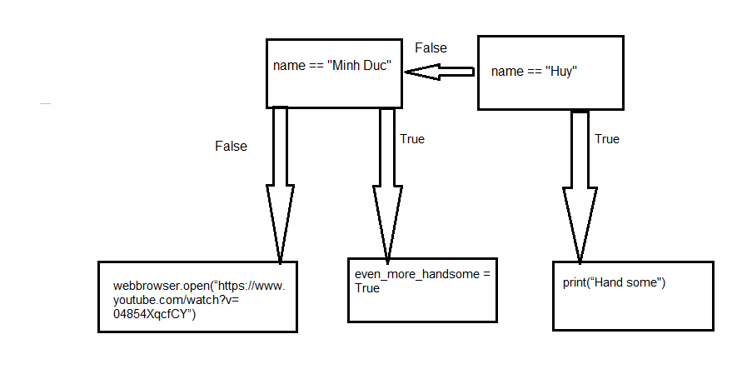

1. Nested conditionals are the ones nested in another conditional.

e.g

a = int(input(“a =”))

if a == 5:

print(“5”)

else:

if a > 5:

print(“ Greater than 5”)

else:

print(“ Smaller than 5”)